

CineTalk

Presented to the

Department of Computer Science

University of San Carlos – Technological Center

In partial fulfillment of the requirements for CS 175 – Android

Submitted by:

Patrick G. Napil

Submitted to:

Paul John Parreño

March 2015

**Table of Contents**

Acknowledgement i

1. Introduction 1

1.1 System Rationale 1

1.2 System Objectives 1

1.2.1 General Objective 1

1.2.2 Specific Objectives 1

1.3 Significance of the System 2

1.4 Scope and Limitations 2

1.4.1 Scope 2

1.4.2 Limitation 2

3. Conclusion and Recommendation 3

3.1 Conclusion 3

3.2 Recommendation 3

User Manual 3

# Introduction

## System Rationale

There are a lot of movie enthusiasts out there searching for places to share their hobby to other people. They even ran out of movies to watch and there is no easy way they could make a list easily unless they share and talk to other people. They could extract from other people what are the good movies to watch and they base it from there whether they watch it or not. It is to make sure that don’t waste time watching movies they don’t want in the first place.

So to response to this kind of situation, the developer made an android app to give them a place to gather and talk about their favorite movies. And read simple reviews of movies to assess the movie before watching.

## System Objectives

### General Objective

The main objective of this research is to develop an android app titled “CineTalk”.

### Specific Objectives

* To develop a good interface for the users.
* To provide good and appropriate UI features to the app.
* To develop Cinetalk with the UI only.
* To evaluate the design of Cinetalk.

## 

## Significance of the System

**Movie Enthusiasts** They can benefit from this because they can talk and express themselves about a certain movie. They could use the comments as a review to consider if the movie is worth watching. Then it will save them time.

**Future Developers** They can use the design of Cinetalk as their bases and inspiration for developing their own android app.

## Scope and Limitations

### Scope

CineTalk have the user interface of the log in and registration page. The app uses tabhost for navigation of the pages. The App can run in the devices.

### Limitation

Cinetalk is only composed of user interface design and doesn’t have any working main functionalities. The ListView implemented in the app is not clickable which means it doesn’t redirect the user to any page and only 1 drawable image is used. It cannot upload in the edit profile page. ListView is not used for showing the favorite movies but it’s clickable and directs the user to a movie page where comments and movie information is found. There no clear settings and it doesn’t work. The images are not well implemented to different screen sizes

# Conclusion and Recommendation

## Conclusion

I conclude that app is good in some aspects of user interface but really bad for user experience. There are a lot of elements that should be improved.

## Recommendation

It is recommended that ViewPager is used instead of TabHost since it is what is used and common nowadays. Actions buttons should be placed in the action bar. Use ListView to use use the space wisely.

**User Manual**

**LOGIN**

1. Open the app.
2. Input username and password
3. Click Login Button

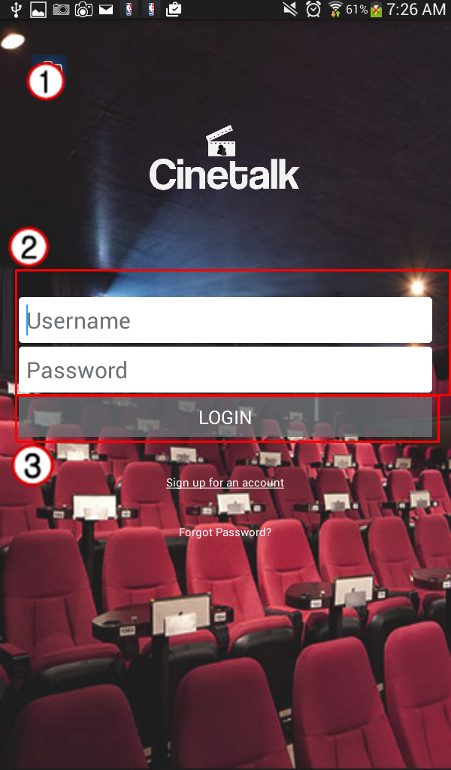

**REGISTRATION**

1. Click Sign up for an account text
2. Input the required fields.
3. Click the Sign up button.

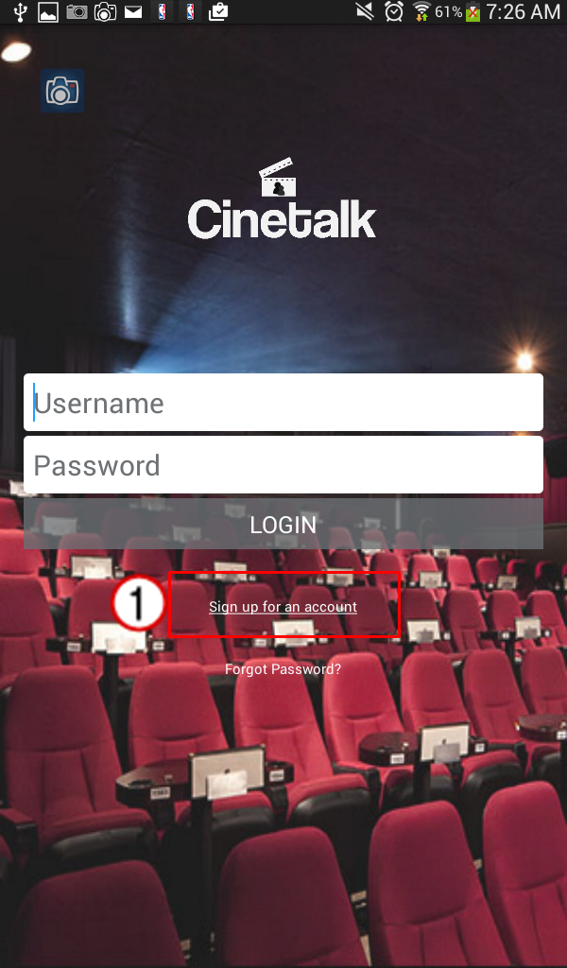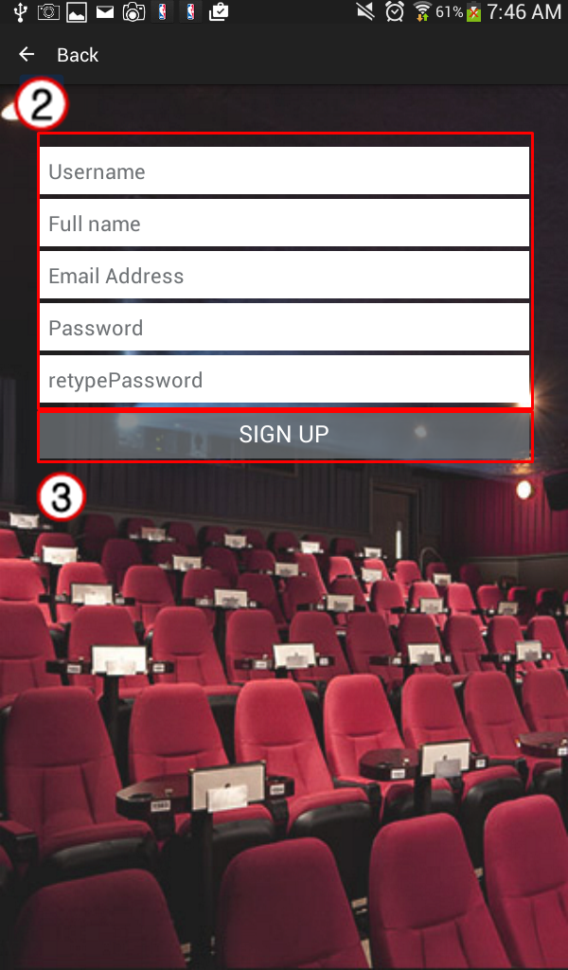

**RETRIEVE PASSWORD**

1. Click Forgot Password? Text
2. Input email address.
3. Click Retrieve Password button.

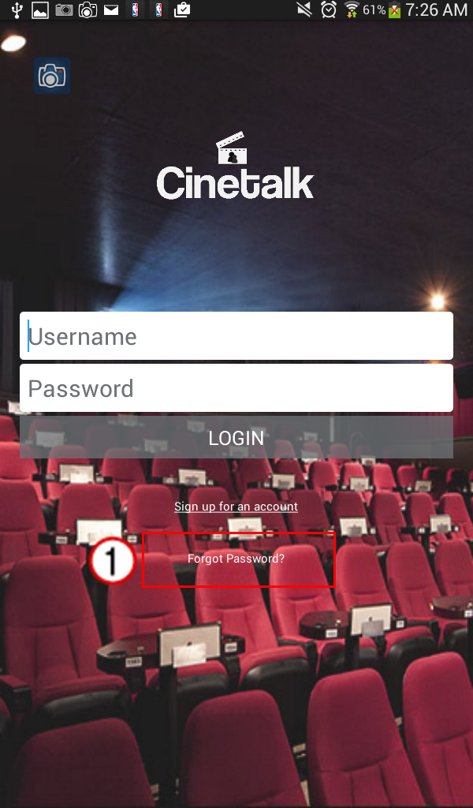 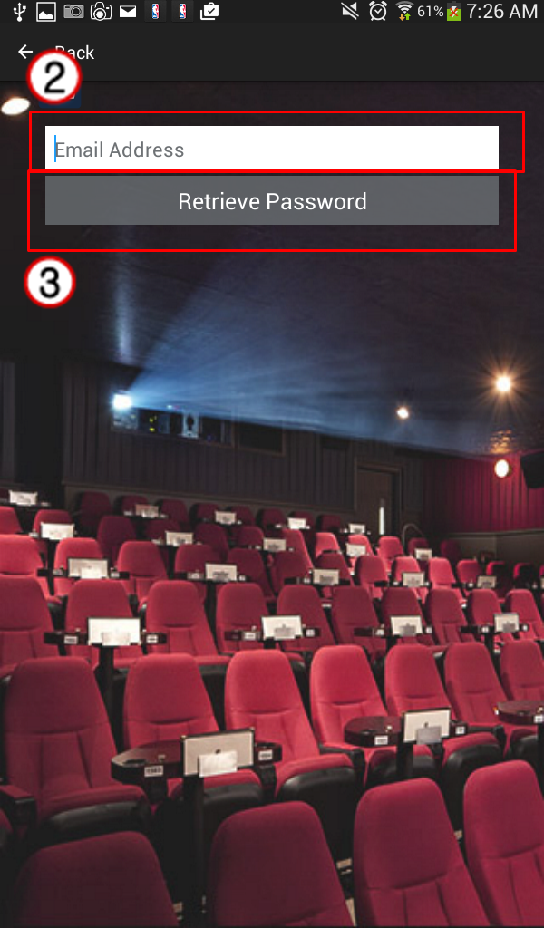

**VIEW TOP USER RATED MOVIES**

1. Login then the user is directed to the homepage.
2. List of Top 10 User rated Movies within the app.
3. The list can be viewed by genre through clicking the spinner.

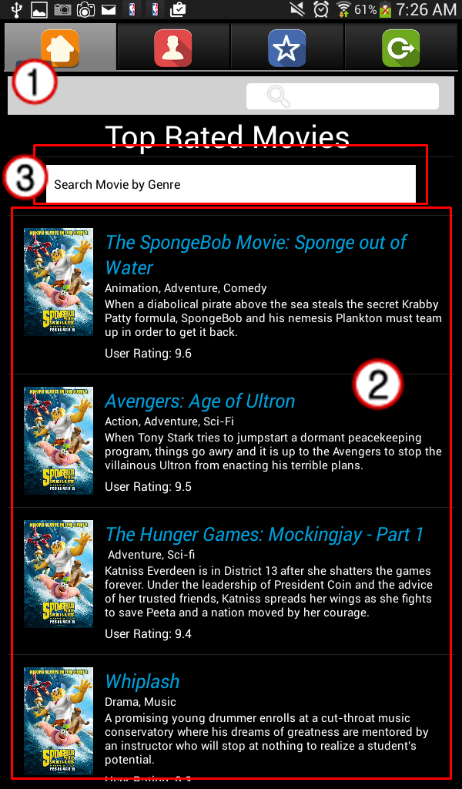

**VIEW AND EDIT PROFILE**

1. Click the Edit Profile button found below part of the profile page.
2. User is directed to an edit page.
3. Input fields that the user wants to edit.
4. Click save button once the desired changes are finished inputted.

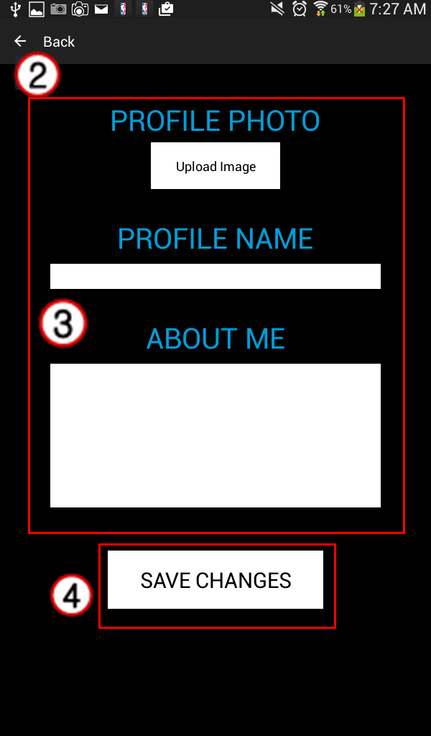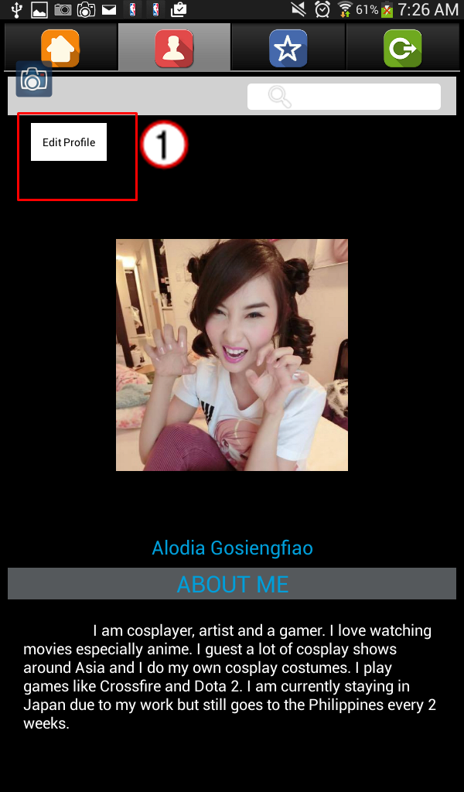

**VIEW FAVORITE MOVIES**

1. Click Favorite Tab with star icon.
2. The list can be viewed by genre through clicking the spinner.

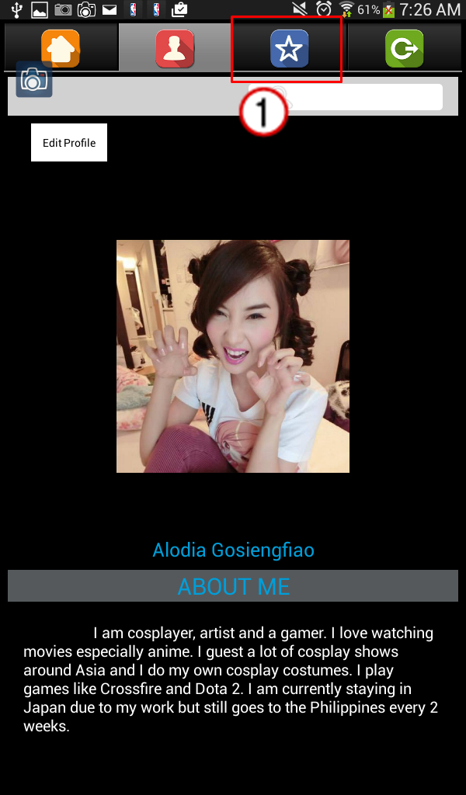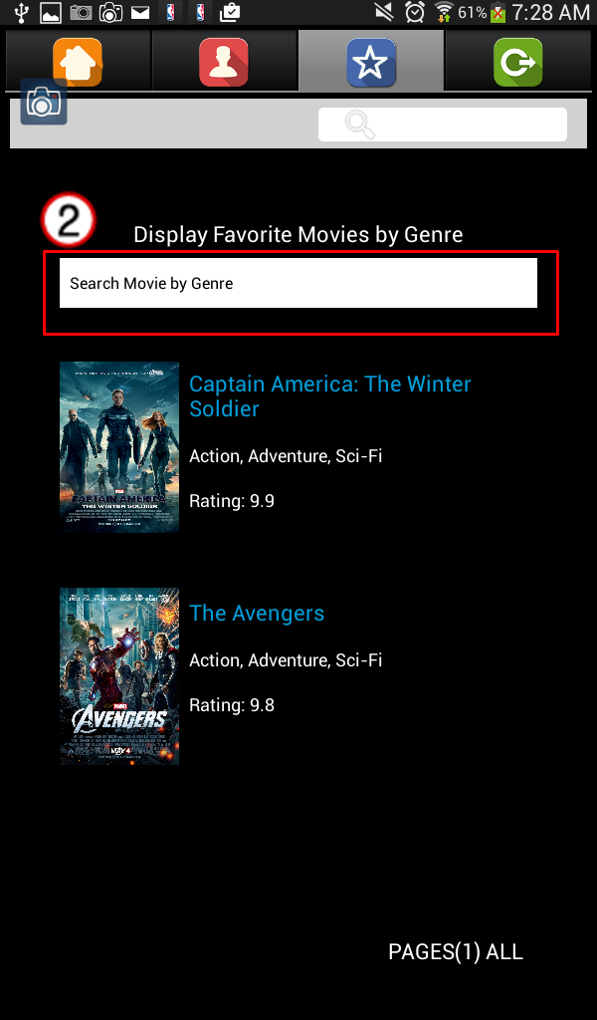

**GO TO SETTINGS**

1. Click the Logout Tab with logout icon.
2. The setting can be seen below the logout button.

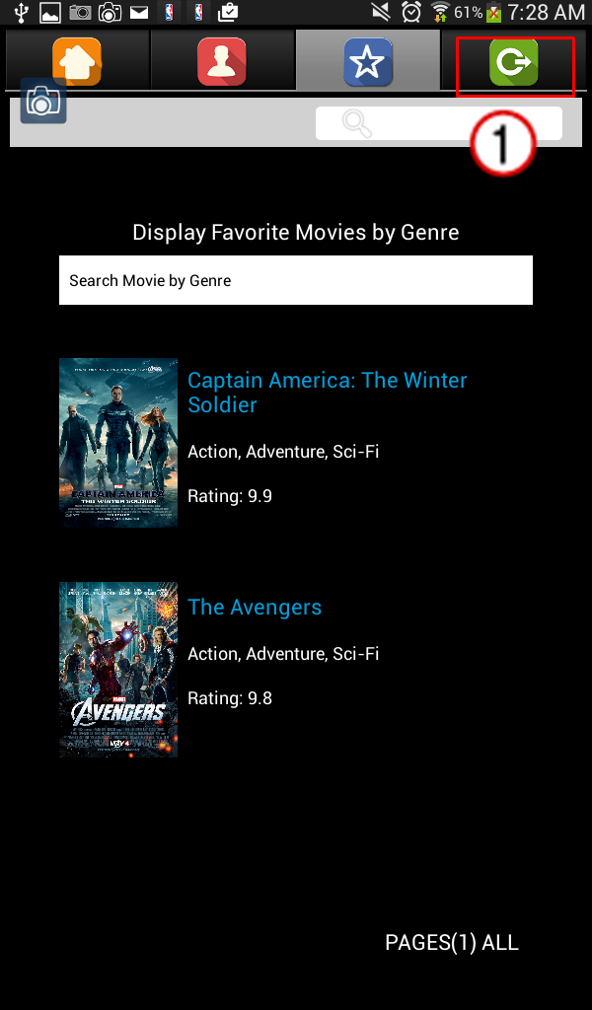 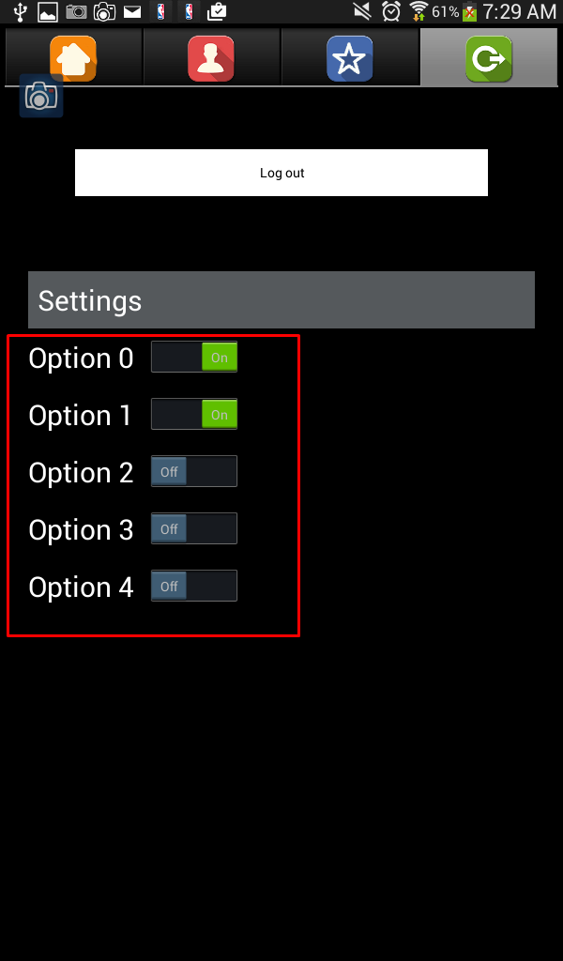

**LOGOUT**

1. Click the Logout button with logout icon.
2. Click logout button.

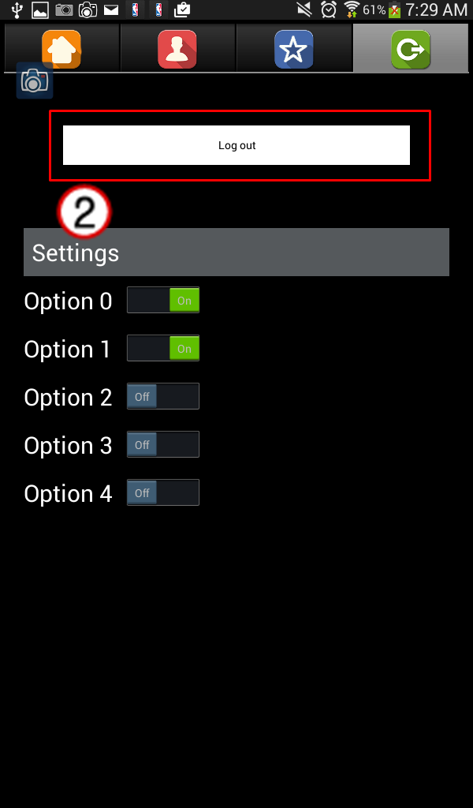

**VIEW MOVIE COMMENTS**

1. Click image of movie.

